JECRC
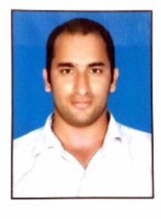
JAIPUR

INDIVIDUAL FACULTY DATA SHEET
Name of the faculty member | : | Kamlesh Kumar Choudhary
Present Designation | : | Assistant Professor
Email Id: hod.ce@jecrc.ac.in kamleshchaudhary.ce@jecrc.ac.in
Contact Details: 9772884422

I. Particulars of Educational Qualification: (only completed)

Category | Name of the Degree | Specialization | Year of Passing | Name of the College | Name of the University
UG | B.TECH | Civil engineering | 2012 | SBCET | RTU KOTA
PG | M.TECH | Transportation engineering | 2014 | MNIT Jaipur | MNIT Jaipur
Ph.D. | - | - | - | - | -

II. Academic Experience : 3.5 Year
III. Industrial Experience : Nil

IV. Title of Ph.D. Thesis : N.A.

V. Awards/Achievements : Nil

VI. Research/Specialization : Transportation Engineering

VII. Course Taught : Civil engineering

VIII. Refereed International Journal Publication : Nil

IX. International Conference Proceeding : Nil

X. Books Written : 01(Basic civil engineering, Neelkanth Publisher)

XI. M.Tech Thesis Guide : Nil

XII. PHD Thesis Guide : Nil

XIII. Professional Body Membership : Nil

